37.3: 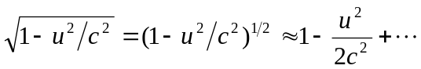
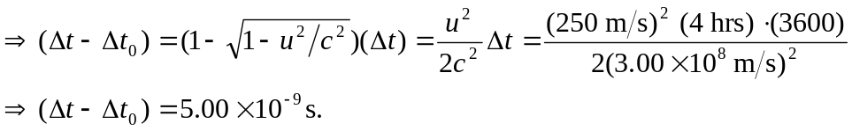
The clock on the plane shows the shorter elapsed time.

